Open University of Sri Lanka
Bachelor of Software Engineering - Final Year Project

Software Requirements Specification (SRS)
A Version-Aware, Ontology-Enhanced Multilingual RAG
Based
Legal Smart Assistant for the Sri Lankan SME Sector

Prepared Date | 2 November 2026
Prepared By | P.K.A. Rashmika (s92082757@ousl.lk 321642757)  K.A.T.S. Kananke Arachchi (s92087400@ousl.lk 721447400)  A.A.A.S. Amarasinghe (s92084962@ousl.lk 221444962)  J. A. Landsberger (s92086001@ousl.lk 521446001)  K.A.I.A.B. Gunasekara (s92064731@ousl.lk 321424731)
Supervisor | Mr. N.M. Siyad

Document Revisions.
Date | Version | Description | Author / Owner
02 Nov 2026 | 1.0 | Comprehensive initial DSRS draft for first progress review | Project Team
08 Nov 2026 | 1.1 | Supervisor-review revision | Project Team
Table 1.1: Document revisions

Document Approval / Review.
Supervisor Review Status | Pending / To be updated after review
Academic Coordinator Submission | 8 November 2026
Confidentiality | Academic project document. Distribution limited to the project team, supervisor, academic staff, and authorized evaluators.
Table 1.2: Document approval and review

TABLE OF CONTENTS

Document Revisions. 2
Document Approval / Review. 2
TABLE OF CONTENTS 3
List of Tables 6
List of Figures 7
1. Introduction 8
1.1 Purpose 8
1.2 Summary 9
1.3 Company Overview / Academic Project Context 9
1.4 Project Overview 10
1.5 Scope 12
1.6 Assumptions 13
1.7 Definitions, Acronyms and Terminology 14
1.8 References 17
2. Project Scope and Impact 19
2.1 Scope Inclusions 19
2.2 Scope Exclusions 19
2.3 Impact on Other Systems 20
2.4 User Classes, Actors and Privileges 21
2.5 Primary User Characteristics 22
3. Functional Requirements 24
3.1 Legal Question Submission and Bilingual Interaction 24
3.2 Date-Aware Legal Query Handling 25
3.3 Hybrid Legal Information Retrieval 25
3.4 Version-Aware Legal Retrieval 27
3.5 Ontology-Assisted Legal Retrieval 27
3.6 Grounded Answer Generation with Citations 28
3.7 Safe Handling of Unsupported Questions 29
3.8 Legal Document Ingestion and Processing 30
3.9 Structure-Aware Legal Chunking and Indexing 31
3.10 Legal Knowledge Review and Publication 32
3.11 Provision Version Management 32
3.12 Ontology and Evidence Mapping Management 32
3.13 Privacy-Protective Query Processing 33
4. Non-Functional Requirements 34
4.1 Performance and Load Requirements 34
4.2 Compatibility Requirements 34
4.3 Certification Requirements 34
4.4 External Interface Requirements 35
4.4.1 User Interfaces 35
4.4.2 Hardware Interfaces 35
4.4.3 Software Interfaces 35
4.4.4 Communications Interfaces 36
4.5 Security and Authentication Requirements 36
4.5.1 Data Storage Security 36
4.5.2 Data Communication Security 36
4.5.3 Authentication 36
4.6 Quality Assurance Requirements 37
4.6.1 QA Test Scope 37
4.6.2 QA Environment 37
4.6.3 QA Data 37
4.7 Development Requirements 38
4.7.1 Development Environment 38
4.7.2 Development Data 39
4.7.3 Coding Standards 39
4.7.4 Implementation Packaging Requirements 40
4.8 Deployment Requirements 40
4.8.1 Installation Packaging Requirements 40
4.8.2 Deployment Requirements 40
4.8.3 Documentation Requirements 40
4.9 Internationalization Requirements 40
4.10 System Activity Log Requirements 41
4.11 Special Documentation Requirements 41
4.12 Applicable Standards 41
4.13 Licensing Requirements 42
4.14 Online User Documentation and Help System Requirements 42
4.15 Purchased Components 42
4.16 Technical Requirements 42
4.17 Supportability Requirements 43
4.18 Reliability Requirements 43
4.19 Usability Requirements 43
5. Pilot Success Criteria 44
5.1 Planned Controlled Comparisons 44
6. Future Requirements 45
7. References 46

List of Tables
Table 1.0.1 Project team members 10
Table 1.0.2 System architecture of the Legal Smart Assistant 12
Table 1.0.3 Functional scope 13
Table 1.0.4 Assumptions 14
Table 1.0.5 Legal terms 14
Table 1.0.6 Technical terms 15
Table 1.0.7 Acronyms 16
Table 2.0.1 Scope inclusions 19
Table 2.0.2 Scope exclusions 20
Table 2.0.3 Impact on other systems 21
Table 2.0.4 User classes, actors and privileges 22
Table 2.0.5 Primary user characteristics 24
Table 4.1 Proposed technology stack 39

List of Figures
Figure 2.0.1 Use case diagram of the Legal Smart Assistant 23
Figure 3.0.1 Hybrid legal information retrieval process 27
Figure 3.0.2 Version-aware selection of a provision by reference date 28
Figure 3.0.3 Question answering activity flow 30
Figure 3.4 Legal content workflow from upload to publication 32

1. Introduction
Small and medium enterprises (SMEs) are the backbone of the Sri Lankan economy. According to the Ministry of Industry and Entrepreneurship Development, micro, small and medium enterprises account for over 75% of all registered businesses, contribute more than 52% of GDP and employ nearly 45% of the workforce (MOIED, 2026). Each of these businesses operates within a legal framework. That framework defines what the business must register, what it must display, what it must report when its circumstances change, and what penalties apply when it does not comply.
For most SME owners this legal framework is difficult to understand. Laws are written in formal legal English and are spread across the original enactment and its later amendments. In some subjects they have been partly replaced by provincial statutes, enacted after Provincial Councils were established under the Thirteenth Amendment to the Constitution (1987). As a result, the rule that applies to a particular business can depend on when the question is asked and where the business operates. An owner who wants a simple answer, such as “Do I have to register my shop’s name, where, and by when?”, often has three options as pay a lawyer for a short consultation, rely on word of mouth, or guess.
Generative AI chatbots appear to offer a free alternative, but they are not reliable for legal questions. They can state incorrect legal rules with confidence (hallucinations), and they rarely cite the provision they rely on. They also have no notion of which version of a law was in force on a given date or in a given province. For legal information, an answer that cannot be traced to its source cannot be trusted.
So, this project responds to that gap with the BNR Legal Smart Assistant, a low-cost, bilingual (Sinhala and English) legal guidance assistant that combines a formal legal ontology with Retrieval-Augmented Generation (RAG). The ontology records each legal provision together with its obligations, penalties, responsible authority, version, effective dates and jurisdiction. When a user asks a question, the system retrieves only the provisions that were legally applicable on the relevant date in the relevant province. A large language model then explains them in plain language and cites the law, section and version behind every statement. When the evidence is insufficient, the assistant declines to answer.
To demonstrate the method in depth rather than breadth, the prototype focuses on business names registration as Business Names Act (No. 7 of 1987). This domain suits the research for three reasons,
- It affects a very large number of small businesses.
- It is often the first legal obligation a new business owner meets.
- It contains the kind of variation that general chatbots handle poorly as national versus provincial law, and the law before versus after an amendment.
Its practical relevance is confirmed by the National SME Strategy Framework (2026), which lists “simplify business name registration process” as a national policy action.

1.1 Purpose
This Software Requirements Specification (SRS) defines the requirements of the BNR Legal Smart Assistant, developed under the project titled “A Version-Aware, Ontology-Enhanced Multilingual RAG-Based Legal Smart Assistant for the Sri Lankan SME Sector.” It sets out completely and unambiguously what the system must do (functional requirements) and how well it must do it (non-functional requirements), before detailed design and implementation begin.
The system is intended to help Sri Lankan SME owners understand their legal obligations under business names law before they pay for a legal consultation. Because the system deals with legal information, errors can have real consequences for its users, such as missed registrations, penalties or wrong decisions. It is therefore essential that the expected behavior of the system is agreed, documented and verifiable from the start. This document provides that foundation.

1.2 Summary
Small and medium enterprises (SMEs) are a major part of Sri Lanka’s economy, but many SME owners struggle to understand their legal obligations. The relevant laws are difficult to read, written mostly in English, and have been changed over time by amendments. As a result, the legal rule that applies to a business can depend on the date on which the question is asked.
Lawyer fees are too high for most SME owners to consult a lawyer for every small legal question, such as what to register, when to register it, and what happens if they do not. Many owners therefore skip legal advice altogether and make decisions based on guesswork or word of mouth, which can lead to penalties, disputes or problems later. General AI chatbots are a free alternative, but they are not reliable for legal questions as they hallucinate legal rules, rarely cite their sources, and cannot tell which version of a law applies on a given date. No existing system gives Sri Lankan SMEs low-cost, reliable, cited and version-correct legal guidance in Sinhala and English.
To address this problem, the project proposes the BNR Legal Smart Assistant, a low-cost, bilingual legal guidance assistant that combines a legal ontology with RAG. The ontology, built in OWL 2 DL using Protégé, models businesses, owners, business names, obligations, penalties, authorities, legal provisions, versions and bilingual legal terms. Each provision is recorded with its status (Active, Amended, Repealed or Superseded) and its effective dates.
When a user asks a question in Sinhala or English, the system identifies the language and the relevant date. It then uses hybrid retrieval, combining vector search with ontology (SPARQL) filtering, to select only the legal provisions that were in force at that time. A large language model (Groq API) uses only these retrieved provisions to give a simple, plain-language answer. Every answer shows the law, section number and version used. When the available evidence is insufficient, or the question is outside the system’s scope, the assistant says so clearly instead of guessing.
To demonstrate the method in depth, the prototype focuses on one legal domain, Business Names Act, No. 7 of 1987. Only the provisions that create obligations for business owners are modelled, registration, changes to particulars, display of the business name, cessation of business, and penalties.
The system will be evaluated using human-reviewed questions in Sinhala and English, comparing Baseline Hybrid RAG with Ontology-Enhanced Hybrid RAG in terms of accuracy, citation correctness and hallucination rate. The evaluation also includes version tests, ontology consistency and competency-question checks, and a usability study with 8–15 SME owners using the System Usability Scale (SUS).
The expected outcome is a working prototype that gives SME owners accurate, cited and version-correct guidance on their legal obligations. It will reduce how often they need expensive legal consultations, and help them get more value from a consultation when they do need one.

1.3 Company Overview / Academic Project Context
This project is an academic final-year group project at The Open University of Sri Lanka (OUSL), carried out by a team of five students under the supervision of Mr. N.M. Siyad. It is a research and development project, not a commercial one, and there is no client company or sponsoring organization. The project is guided by the academic requirements of the university and will be assessed through progress reviews, a final demonstration and a final project report.
The project serves the Sri Lankan SME community, particularly sole proprietors, small business owners and people who are about to start a business. These users often need basic legal guidance but cannot afford to consult a lawyer for every question. The project also benefits secondary users such as business-studies students, SME support officers and development agencies, who need reliable and easy-to-understand information on SME legal obligations.
The project team consists of the following members,

Table 1.0.1 Project team members
Team Member | Student No. | Email
P.K.A. Rashmika | 321642757 | s92082757@ousl.lk
K.A.T.S. Kananke Arachchi | 721447400 | s92087400@ousl.lk
A.A.A.S. Amarasinghe | 221444962 | s92084962@ousl.lk
J. A. Landsberger | 521446001 | s92086001@ousl.lk
K.A.I.A.B. Gunasekara | 321424731 | s92064731@ousl.lk

A practicing lawyer supports the project as the legal content validator. The validator reviews how the law is represented in the system’s ontology and confirms the correct answers in the evaluation test set. This ensures that the system’s legal content and evaluation results are accurate and credible.
The project follows the Design Science Research (DSR) methodology (Hevner et al., 2004; Peffers et al., 2007). DSR is widely used in information systems research when the goal is to design and evaluate an innovative IT artefact that solves a real-world problem. In this project, the artefact is the BNR Legal Smart Assistant and its legal ontology. The research moves through the DSR activities of problem identification, definition of solution objectives, design and development, demonstration, evaluation and communication of results.
Within this research approach, the system is developed using the Agile method in two-week sprints. Each sprint produces a working part of the system, which is reviewed against the requirements in this document before the next sprint begins. This allows the team to receive regular feedback from the supervisor, detect problems early and adjust the work when needed. All source code, ontology files and project documents are managed in a shared GitHub repository to support version control and teamwork.

1.4 Project Overview
The Legal Smart Assistant is a web-based legal guidance system that helps Sri Lankan SME owners understand their legal obligations relating to business names. The prototype domain is business-name registration, changes to registered particulars, basic post-registration duties and cancellation, for sole proprietors and partnerships in Sri Lanka. The system answers legal questions in Sinhala and English, explains the relevant law in simple language, and shows the exact legal source behind every answer.
The system combines two technologies. The first is a legal ontology, a formal model of the legal domain built in OWL 2 DL using Protégé. The ontology describes businesses, owners, business names, obligations, penalties, authorities, legal provisions and their versions, and it includes legal terms in both Sinhala and English. Each legal provision is recorded with its status (Active, Amended, Repealed or Superseded) and its effective dates. The system can therefore identify which version of the law applied on a given date.
The second technology is RAG. Instead of letting a language model answer from its general knowledge, RAG first retrieves the relevant legal provisions from a trusted legal collection. The language model then generates its answer using only those provisions. This approach reduces the risk of incorrect or invented legal information, which is a common problem with general AI chatbots.
The system is organized into two main parts,
- Legal knowledge preparation (back office). The official legal texts are collected, cleaned and split section by section according to their legal structure. Each section is linked to its matching entry in the ontology, together with its version and effective dates. When the law changes through an amendment or repeal, the new version is added through a review process, so the system always holds both the current and the earlier versions of the law.
- Question answering (front office). When a user asks a question, the system identifies the language of the question and the date for which the law should be applied. It then performs hybrid retrieval, combining vector search, which finds legal text with a similar meaning to the question, with ontology filtering using SPARQL, which keeps only the provisions that were valid on that date. The language model (Groq API) uses these provisions to produce a clear, plain-language answer. The answer includes citations showing the law, section number and version used. If the system cannot find enough legal evidence, or the question is outside its scope, it says so clearly instead of guessing.
The main features available to users are,
- Legal question and answer chat in Sinhala or English.
- Citations and a sources panel, where the user can view the law, section and version behind each answer and read the original legal text.
- Date/version selector, allowing the user to ask what the law required on a specific date.
- Clear safety responses, including “insufficient evidence” and “out of scope” messages, and a legal disclaimer stating that the system provides guidance and not legal advice.
Given below is the System Architecture Diagram for the “A Version-Aware, Ontology-Enhanced Multilingual RAG-Based Legal Smart Assistant for the Sri Lankan SME Sector” system.
Table 1.0.2 System architecture of the Legal Smart Assistant
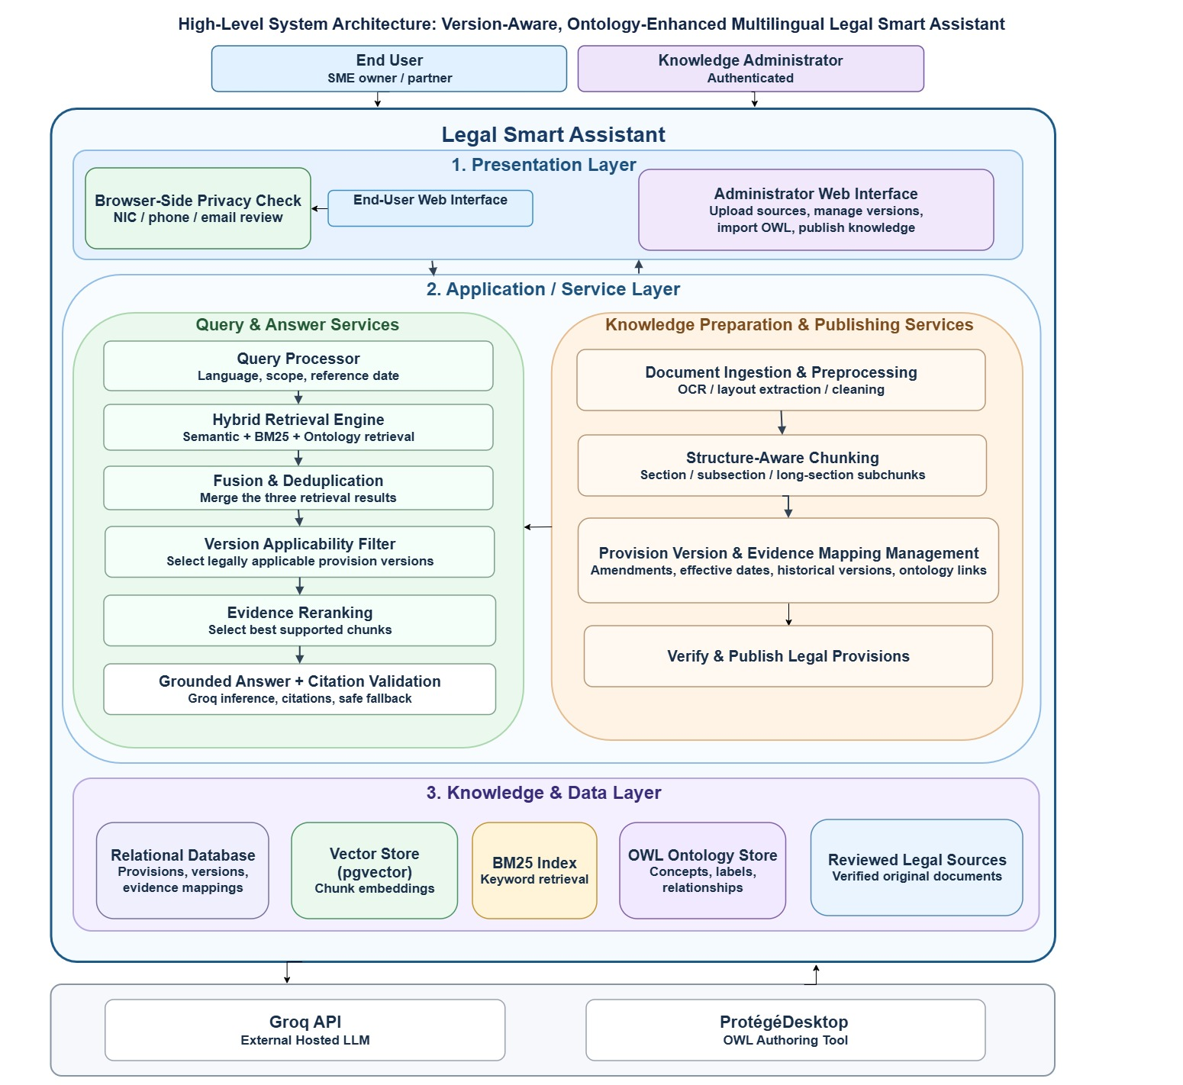

1.5 Scope
The scope of this project is limited to a working prototype of the Legal Smart Assistant. The prototype demonstrates the proposed method in depth on one selected legal domain, rather than covering many laws at a basic level. This keeps the project achievable within the academic timeline and allows the legal content to be fully modelled and validated by a lawyer.
Legal scope
The prototype covers the Business Names Act (No. 7 of 1987). The prototype domain is business-name registration, changes to registered particulars, basic post-registration duties and cancellation, for sole proprietors and partnerships in Sri Lanka. Only the provisions that create obligations for business owners are modelled,
- Registration of a business name
- Changes to registered particulars
- Basic post-registration duties, such as display of the business name
- Cancellation of registration when the business ceases
- Penalties for non-compliance
Intended users
- Primary users - SME owners, sole proprietors, partners in small firms and people who are about to start a business.
- Secondary users - business-studies students, SME support officers and development agencies.
Functional scope
Table 1.0.3 Functional scope
No. | Function | Description
1 | Legal ontology | OWL 2 DL ontology built in Protégé, modelling businesses, owners, business names, obligations, penalties, authorities, legal provisions, versions and bilingual legal terms
2 | Version awareness | Each provision has a status (Active / Amended / Repealed / Superseded) and effective dates
3 | Document processing | The law text is split section by section, and each section is linked to its matching ontology entry
4 | Hybrid retrieval | Vector search combined with ontology (SPARQL) filtering by version and date
5 | Answer generation | The LLM (Groq API) gives a simple answer using only the retrieved sections
6 | Citations | Every answer shows the law, section number and version used
7 | Multilingual support | Questions and answers in Sinhala and English
8 | Web interface | Chat screen, sources panel, date/version selector and a legal disclaimer
Evaluation scope
- Approximately 60 human-reviewed cases in Sinhala and English.
- A comparison of plain RAG with ontology-enhanced RAG (accuracy, citation correctness and hallucination rate).
- Version tests - whether the correct version of the law is returned for a given date.
- Ontology checks - consistency (HermiT) and competency questions (SPARQL).
- A usability test with approximately 5 participants using the System Usability Scale (SUS).

1.6 Assumptions
The requirements in this document are based on the following assumptions. If any of these assumptions proves to be incorrect during the project, its impact will be assessed and this document will be updated.
Table 1.0.4 Assumptions
ID | Assumption | Impact if Invalid
01 | The official text of the Business Names Act, No. 7 of 1987 and its amendments can be obtained in a readable digital or scannable form. | Legal content coverage will be reduced, and manual typing of the legal text may be required.
02 | A qualified lawyer is available to validate the legal content of the ontology and the 80–100 question test set. | The accuracy of the evaluation results will be weaker, and the findings must be presented with limitations.
03 | Official or reliable Sinhala versions of the selected legal provisions are available, or accurate translations can be prepared and validated. | Sinhala answers will depend on translations of English text, which increases the risk of terminology errors.
04 | A multilingual embedding model with adequate Sinhala support is available for free or open-source use. | Retrieval quality for Sinhala questions may be lower, and translation-based retrieval may be needed.
05 | Users have access to a modern web browser and an internet connection. | An offline or low-bandwidth version of the system would need to be designed.
06 | The selected provisions have changed over time, through amendments or new versions, so that version-aware retrieval can be meaningfully tested. | Version testing will be limited, and test cases may need to rely on simulated versions.

1.7 Definitions, Acronyms and Terminology
This section defines the legal terms, technical terms and acronyms used in this document, so that readers from both legal and computing backgrounds share the same understanding.
Legal terms
Table 1.0.5 Legal terms
Term | Definition
Business name | The name under which an individual or firm carries on business. A business name that is not the owner’s own true name generally has to be registered.
Sole proprietor | An individual who owns and runs a business alone and is personally responsible for it.
Partnership | A business owned and run by two or more persons who share its profits and responsibilities.
Registrar of Business Names | The officer responsible for registering business names and maintaining the register.
Act | An enactment of the Legislature of Sri Lanka (or Ceylon) enacted on or after October 14, 1947, excluding laws enacted by past National State Assemblies
Provision | A legally meaningful unit of a law as a section, subsection, paragraph, proviso or schedule item.
Provision version | The text and details of a provision that were valid for a specific period of time.
Registered particulars | The details recorded at registration, such as the business name, the nature and place of the business, and the names of the owners or partners.
Amendment | A change to the text or effect of a provision made by a later law.
Repeal | The removal of a provision from the law by a later law.
Superseded | A provision that has been replaced by a newer provision and no longer applies.
Effective date | The date from which (effective-from) or until which (effective-to) a provision version is in force.
Obligation | A duty that the law places on a business owner, such as to register, to display the business name or to notify changes.
Penalty | The legal consequence of failing to meet an obligation, such as a fine.
Cancellation | The removal of a business name from the register, for example when the business stops operating.
Reference date | The date for which the user wants to know the law. If no date is given, the current date is used.
Technical terms
Table 1.0.6 Technical terms
Term | Definition
Retrieval-Augmented Generation (RAG) | A technique in which a language model first retrieves relevant documents from a trusted source and then generates its answer based on them, instead of relying only on what it learned during training.
Plain RAG | RAG that uses only vector similarity search, without ontology filtering. It is used as the baseline in the evaluation.
Ontology-enhanced RAG | RAG in which retrieval is filtered and expanded using the legal ontology, for example by version, date and related legal concepts.
Large Language Model (LLM) | An AI model trained on large amounts of text that can understand and generate human language. This project accesses one through the Groq API.
Ontology | A formal, machine-readable model of the concepts in a domain and the relationships between them.
OWL 2 DL | Web Ontology Language 2, Description Logic profile as a W3C standard for building ontologies that supports automated reasoning.
SPARQL | The W3C query language for ontology and RDF data. In this project it is used to select legal provisions by version and date.
RDF | Resource Description Framework as the data model on which OWL ontologies are built.
Reasoner (HermiT) | Software that checks an ontology for logical errors and infers new facts from its rules.
Protégé | A free, open-source ontology editor developed by Stanford University.
LKIF Core | A reference ontology of basic legal concepts, used to align the project ontology with established legal modelling practice.
Competency question | A question the ontology must be able to answer, used to check that it covers the domain correctly.
Embedding | A list of numbers (a vector) that represents the meaning of a piece of text, used to find text with similar meaning.
Vector database | A database that stores embeddings and quickly finds those most similar to a question (e.g. ChromaDB or FAISS).
Chunk | A piece of legal text, such as one section, that is stored and searched separately.
Hybrid retrieval | A retrieval method that combines vector (meaning-based) search with ontology-based filtering.
Evidence set | The legal provisions retrieved for a question and passed to the language model to generate the answer.
Grounded answer | An answer in which every statement is supported by, and cited to, the retrieved legal provisions.
Citation | A reference showing the law, section number and version on which a statement in the answer is based.
Hallucination | A statement produced by a language model that is not supported by the legal sources or is legally incorrect.
Prompt | The instructions and information sent to the language model.
Acronyms
Table 1.0.7 Acronyms
Acronym | Meaning
AI | Artificial Intelligence
API | Application Programming Interface
DSR | Design Science Research
GDP | Gross Domestic Product
LLM | Large Language Model
MoSCoW | Must have, should have, could have, Won’t have
OUSL | The Open University of Sri Lanka
OWL | Web Ontology Language
RAG | Retrieval-Augmented Generation
RDF | Resource Description Framework
SME | Small and Medium Enterprise
SPARQL | SPARQL Protocol and RDF Query Language
SRS | Software Requirements Specification
SUS | System Usability Scale
UI | User Interface
W3C | World Wide Web Consortium

1.8 References
[1] Ministry of Industry and Entrepreneurship Development, National SME Strategy Framework: A Thriving Nation – A Beautiful Life, Ver. 1.0. Colombo, Sri Lanka: MOIED, 2026.
[2] P. Lewis et al., “Retrieval-augmented generation for knowledge-intensive NLP tasks,” in Proc. Adv. Neural Inf. Process. Syst. (NeurIPS), vol. 33, 2020, pp. 9459–9474.
[3] Business Names Ordinance, No. 6 of 1918, Chapter 149, Legislative Enactments of Ceylon.
[4] W3C OWL Working Group, “OWL 2 Web Ontology Language document overview (second edition),” W3C Recommendation, Dec. 2012. [Online]. Available: https://www.w3.org/TR/owl2-overview/
[5] S. Harris and A. Seaborne, “SPARQL 1.1 query language,” W3C Recommendation, Mar. 2013. [Online]. Available: https://www.w3.org/TR/sparql11-query/
[6] J. Brooke, “SUS: A ‘quick and dirty’ usability scale,” in Usability Evaluation in Industry, P. W. Jordan, B. Thomas, B. A. Weerdmeester, and I. L. McClelland, Eds. London, U.K.: Taylor & Francis, 1996, pp. 189–194.
[7] A. R. Hevner, S. T. March, J. Park, and S. Ram, “Design science in information systems research,” MIS Quart., vol. 28, no. 1, pp. 75–105, 2004.
[8] K. Peffers, T. Tuunanen, M. A. Rothenberger, and S. Chatterjee, “A design science research methodology for information systems research,” J. Manage. Inf. Syst., vol. 24, no. 3, pp. 45–77, 2007.
[9] B. Glimm, I. Horrocks, B. Motik, G. Stoilos, and Z. Wang, “HermiT: An OWL 2 reasoner,” J. Autom. Reasoning, vol. 53, no. 3, pp. 245–269, 2014.
[10] R. Hoekstra, J. Breuker, M. Di Bello, and A. Boer, “The LKIF core ontology of basic legal concepts,” in Proc. Workshop Legal Ontologies Artif. Intell. Techn. (LOAIT), Stanford, CA, USA, 2007, pp. 43–63.

2. Project Scope and Impact

2.1 Scope Inclusions
The following items are included in this release of the Legal Smart Assistant,
Table 2.0.1 Scope inclusions
ID | Included Item
01 | An OWL 2 DL legal ontology covering business-name registration, changes to registered particulars, post-registration duties, cancellation and penalties under the Business Names Act, No. 7 of 1987.
02 | Coverage of sole proprietorships and partnerships as the business types in scope.
03 | Version information for every modelled provision, including its status (Active, Amended, Repealed or Superseded) and its effective-from and effective-to dates.
04 | Collection, cleaning and section-by-section chunking of the legal text, with each section linked to its matching ontology entry.
05 | Hybrid retrieval combining multilingual vector search with ontology (SPARQL) filtering by version and date.
06 | Answer generation using the Groq API, restricted to the retrieved legal provisions.
07 | Citations in every answer showing the law, section number and version used.
08 | Questions and answers in Sinhala and English.
09 | A date/version selector allowing users to ask what the law required on a specific date.
10 | Clear “insufficient evidence” and “out of scope” responses, and a legal disclaimer.
11 | A web interface with a chat screen, sources panel, date/version selector.
12 | Basic administration functions for managing legal content, provision versions and system settings.
13 | Evaluation using a lawyer-validated test set of 80–100 questions, a comparison of plain RAG and ontology-enhanced RAG, version tests, ontology checks and an SUS usability study.

2.2 Scope Exclusions
The following items are not included in this release,
Table 2.0.2 Scope exclusions
ID | Excluded Item | Reason
01 | Laws other than the Business Names Act, such as tax, labour, EPF/ETF and company law. | The project focuses on depth in one legal domain rather than covering many laws at a basic level.
02 | Business types other than sole proprietorships and partnerships, such as companies. | Companies are registered under different legislation.
03 | Formal legal advice, legal opinions or legal representation. | The system is a legal information tool and does not replace a lawyer.
04 | Case law and court judgments. | These require separate legal analysis and modelling.
05 | Tamil language support. | Planned as future work.
06 | Online submission of registration forms or payment of fees. | There is no official system interface available, and this is outside the academic scope.
07 | Automatic monitoring of new amendments in the Government Gazette. | Legal updates are added manually and reviewed before use.
08 | Training or fine-tuning of a language model. | The system uses an existing language model with retrieval-based grounding.
09 | Native mobile applications. | A responsive web interface is sufficient for the prototype.
10 | Production-level hosting with high availability. | The prototype is deployed only for demonstration and evaluation.

2.3 Impact on Other Systems
The Legal Smart Assistant is a stand-alone prototype. It does not connect to, change or write data into any government system or other external system. It does, however, depend on the external services and resources listed below.
Table 2.0.3 Impact on other systems
External System / Resource | Interaction | Impact
Groq API | The system sends the user’s question and the retrieved legal provisions, and receives the generated answer. | Usage cost and rate limits apply. Only the information needed to answer the question is sent.
Multilingual embedding model | Converts legal text and user questions into vectors for similarity search. | If the model is changed, all legal text must be processed again.
Vector database (e.g. PostgreSQL or FAISS) | Stores and searches the legal text vectors. | Internal component with no external impact.
Ontology and SPARQL engine | Stores the legal ontology and filters provisions by version and date. | Internal component. The ontology is created and updated in Protégé.
Official legal sources | The legal texts are obtained and added to the system manually. | Read-only use. No automatic collection from government websites.
GitHub | Used for source code storage, version control and team collaboration. | No impact on the running system.

2.4 User Classes, Actors and Privileges
The Legal Smart Assistant has two main actors as the SME User and the Administrator. Each actor has a different role and a different level of access to the system’s functions.
Table 2.0.4 User classes, actors and privileges
Actor | Description | Privileges
SME User | An SME owner, sole proprietor, partner or prospective business owner who uses the system to understand their legal obligations. Secondary users, such as business-studies students and SME support officers, also belong to this class. | Submit compliance questions in Sinhala or English, receive generated answers, view source citations, access the official source documents and submit feedback on answers.
Administrator | An authorized project team member responsible for managing the legal content and the operation of the system. | Log in to the administration area, upload official documents, review and approve documents, manage document versions, trigger document reindexing, review audit logs and manage ontology evidence links.

The interactions between the actors and the system functions are shown in the use case diagram in Figure 2.
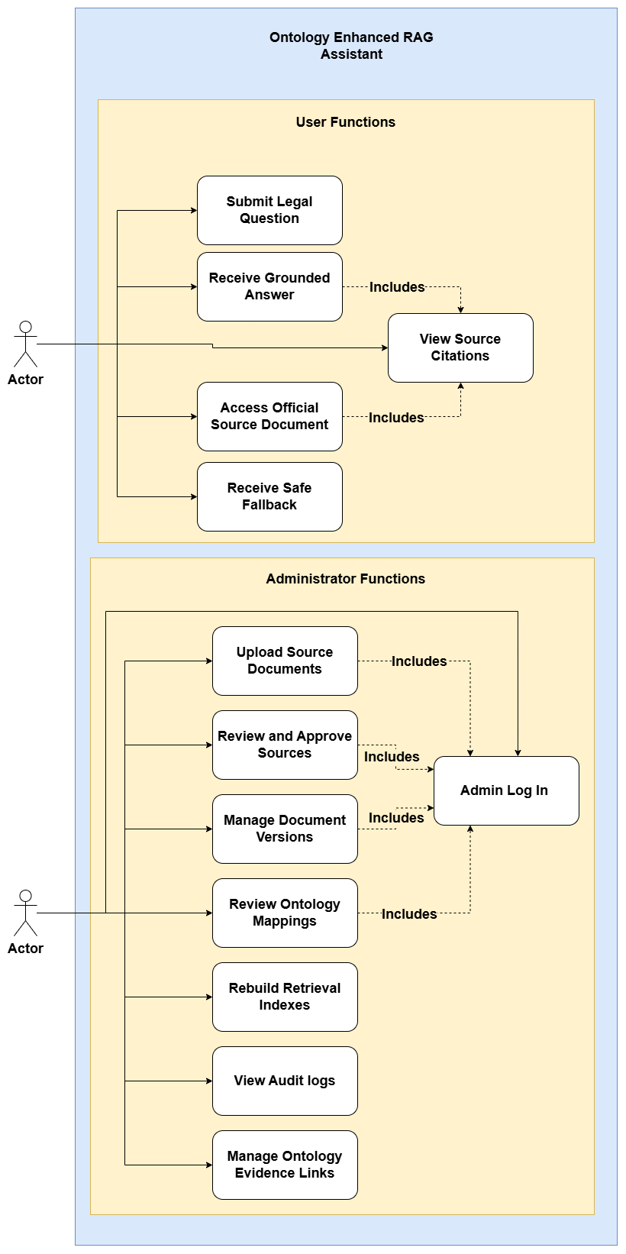
Figure 2.0.1 Use case diagram of the Legal Smart Assistant
The SME User can submit a compliance question and receive a generated answer. Receiving an answer always includes viewing the source citations, so the user can see the law, section and version on which the answer is based. From the citations, the user can optionally access the official source document to read the original legal text (an extend relationship). The user can also submit feedback on an answer to help improve the system. And The Administrator manages the legal knowledge used by the system. The administrator uploads official legal documents, reviews and approves them, and manages document versions when the law is amended or repealed. Reindexing is triggered after changes, so that the system always searches the latest approved content. The administrator also reviews audit logs and manages the links between legal text and ontology concepts (ontology evidence links). Reviewing and approving documents, managing document versions and triggering reindexing all include administrator login, so only authorized users can change the legal content. Business-name registration, changes to registered particulars, basic post-registration duties and cancellation for sole proprietors and partnerships in Sri Lanka.

2.5 Primary User Characteristics
The primary users of the Legal Smart Assistant are SME owners, sole proprietors, partners in small firms, employers, employees and people who are about to start a business in Sri Lanka. Owners and employers use the system to understand their own legal obligations. Employees use it to understand the legal duties of the business they work for, and they may also be responsible for tasks such as registration, updating details or displaying the business name on their employer’s behalf. Most of these users work in small businesses with limited resources and need quick, reliable legal information without the cost of consulting a lawyer for every question. Their main characteristics, and how the system responds to them, are described below.

Table 2.0.5 Primary user characteristics
Characteristic | Description | Design Response
Legal knowledge | Most users, including owners, employers and employees, have little or no legal training and find legal language difficult to understand. | Answers are written in simple language, legal terms are explained, and the original legal text is available through the source citations.
Language | Many users prefer Sinhala, some prefer English, and some mix both languages in one question. | Questions and answers are supported in Sinhala and English, and the answer is given in the language of the question.
Digital skills | Users range from basic smartphone users to confident computer users. | A simple chat-based interface with few steps, which works on mobile phones and computers.
Time and cost | Owners and employers have limited time and money, and employees often need answers quickly while doing their work. | Fast responses, free use, and clear answers that focus on what the user needs to do.
Role in the business | Owners and employers are legally responsible for compliance, while employees may carry out compliance tasks for the business. | Answers explain the obligation, who is responsible for it and what needs to be done.
Trust | Users need to be confident that the legal information is correct and up to date. | Every answer includes citations showing the law, section and version, with access to the official source document.
Goal | Users want to understand their legal position before deciding whether to consult a lawyer. | The system gives clear guidance, shows a legal disclaimer and recommends a lawyer for complex or disputed matters.
Feedback | Users may find some answers unclear or incomplete. | Users can submit feedback on answers, which helps the team identify gaps and improve the system.

3. Functional Requirements
This section describes the functional requirements of the Legal Smart Assistant, that is, the functions the system must provide to its users and administrators. These requirements define how the system accepts legal questions in Sinhala and English, retrieves the relevant legal provisions, selects the correct version of the law for a given date, and generates grounded answers with citations. They also cover how legal documents are processed, reviewed, versioned and linked to the ontology, so that only accurate and approved legal knowledge is used by the system. The functional requirements in this section are based on the use cases shown in Figure 2 (Section 2.4).
For clarity, the functional requirements are divided into twelve sections according to the main functions of the system. Sections 3.1 to 3.7 describe the functions that support the end user submitting questions, handling dates, retrieving legal information, using the ontology, generating answers with citations, and safely handling unsupported questions. Sections 3.8 to 3.12 describe the functions that support the administrator in managing the legal knowledge of the system: document ingestion and processing, structure aware chunking and indexing, review and publication of legal content, provision version management, and ontology and evidence mapping management. Together, these sections define the complete set of functions needed for the prototype.

3.1 Legal Question Submission and Bilingual Interaction
The system shall allow the end user to ask legal questions in Sinhala or English and receive answers in the selected language.
  - The system shall allow the user to type and submit a legal question through a chat interface.
  - The system shall accept questions written in Sinhala, English or a mix of both.
  - The system shall give the response in the language selected by the user, or in the language of the question if no language is selected.
  - The system shall allow the user to switch the interface and answer language between Sinhala and English.
  - The system shall validate submitted questions and reject empty inputs, excessively long queries, or inputs containing only unsupported characters, displaying an appropriate error message.
  - When the user submits a follow-up question, the system shall use the available conversation context to interpret the question while preserving the original legal reference date and jurisdiction unless the user explicitly changes them.
  - The system shall keep the context of a short conversation so that the user can ask follow up questions.
  - The system shall show example questions in Sinhala and English to guide first time users.
  - The system shall allow the user to submit feedback on an answer.

3.2 Date-Aware Legal Query Handling
The system shall answer according to the current law by default, and allow the user to ask about the law on a past date.
- The system shall use the current date as the default reference date when no date is given.
- The system shall provide an "as of" date selector so the user can ask a historical legal question.
- The system shall determine the legal reference date using a defined precedence rule. An explicitly selected reference date shall take precedence over dates extracted from the question. If no reference date is provided, the current date shall be used.
- The system shall validate the selected reference date and notify the user when the date cannot be interpreted or when the available legal corpus does not contain sufficient evidence for that date.
- The system shall recognize dates mentioned in the question, such as "in 2015" or "when I registered in 2019".
- The system shall use the reference date to decide which legal provision version applies.
- The system shall show the reference date used together with the answer.

3.3 Hybrid Legal Information Retrieval
The system shall find relevant legal information by combining three retrieval methods. The hybrid retrieval process is shown in Figure 3.
- The system shall perform semantic (vector) retrieval to find legal text with a similar meaning to the question.
- The system shall perform BM25 keyword retrieval to find legal text containing the important words in the question.
- The system shall perform ontology-based retrieval to find provisions linked to the legal concepts in the question.
- The system shall combine evidence candidates retrieved through semantic vector search, BM25 keyword search, and ontology-guided retrieval using a defined rank-fusion method before final reranking.
- The system shall remove duplicate results from the combined list.
- The system shall rerank the combined results and select the most relevant evidence for answer generation.
- The system shall filter retrieved evidence according to its approval status, legal reference date, and verified jurisdictional applicability before passing it to the answer-generation component.
- The system shall preserve the original document identifier, legal provision identifier, version identifier, and source metadata throughout retrieval, fusion and reranking.
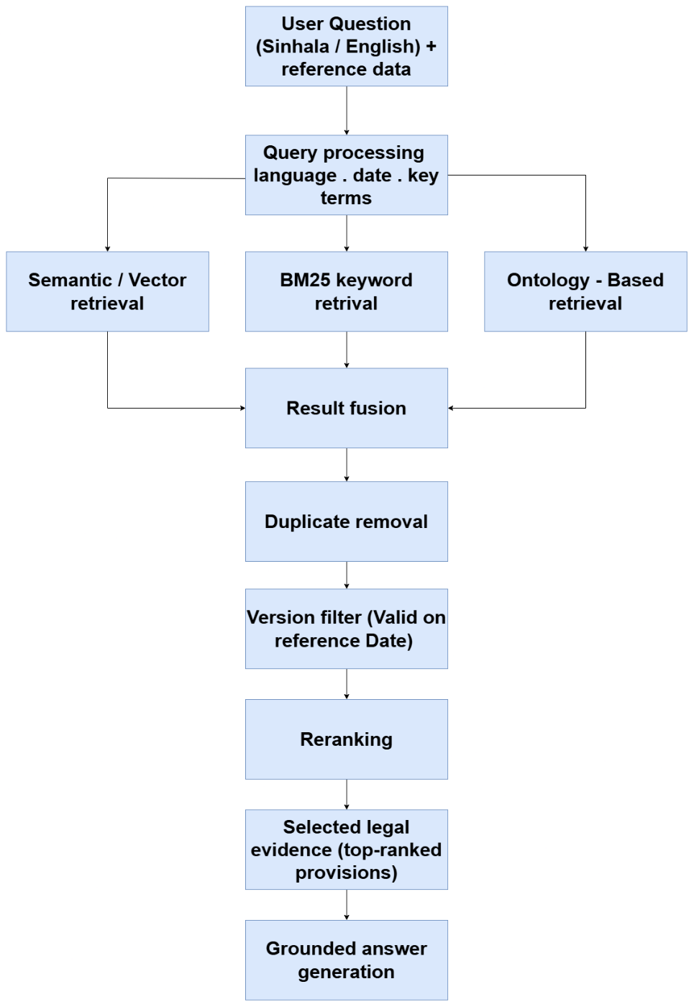
Figure 3.0.1 Hybrid legal information retrieval process

3.4 Version-Aware Legal Retrieval
The system shall retrieve the version of each legal provision that was valid on the reference date. Figure 4 shows how the reference "as of" date selects the applicable version.
- Each provision version shall have an effective-from date and, where applicable, an effective-to date.
- The system shall select only the provision versions that were valid on the reference date.
- Historical versions shall be kept, so that the system can answer both current and past date questions.
- The system shall never present an old or repealed provision as current law.
- The system shall clearly label older versions with their effective period when they are shown.
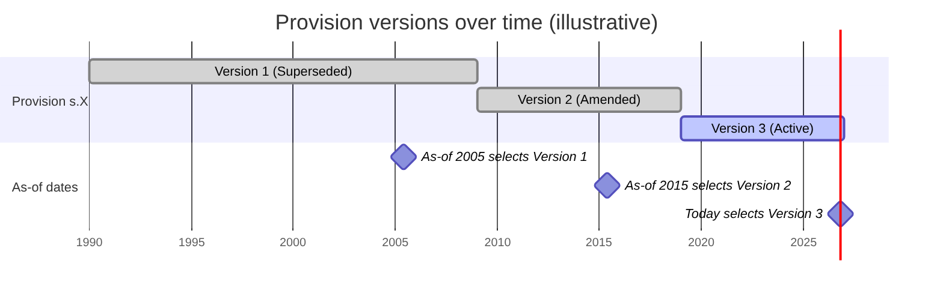
Figure 3.0.2 Version-aware selection of a provision by reference date

3.5 Ontology-Assisted Legal Retrieval
The system shall use the domain ontology to understand the question and find related legal information.
- The system shall identify the legal concepts in the question, such as business types, owners, partners, registration, changes, cancellation, forms, deadlines and penalties.
- The system shall use ontology relationships to find related information, such as the deadline, form or penalty linked to an obligation.
- Sinhala and English labels and synonyms shall refer to the same ontology concepts.
- The system shall use ontology concepts, relationships, and verified concept-to-provision mappings to expand queries, identify related legal evidence, and support retrieval filtering without replacing the semantic and keyword retrieval mechanisms.

3.6 Grounded Answer Generation with Citations
The system shall generate answers only from the selected legal evidence and show the sources used. The complete question answering flow, including the fallback path for unsupported questions, is shown in Figure 5.
- The system shall generate the answer using only the selected legal evidence.
- The system shall write the answer in simple, clear language suitable for SME users.
- Each answer shall include citations showing the source document, section or subsection, provision version and page reference where available.
- The system shall validate that each generated legal citation refers to an approved retrieved provision and shall check whether the cited evidence supports the corresponding factual claim before presenting the response.
- The user shall be able to open a citation and view the supporting legal source.
- The system shall display a legal disclaimer stating that it provides legal information only, not legal advice.
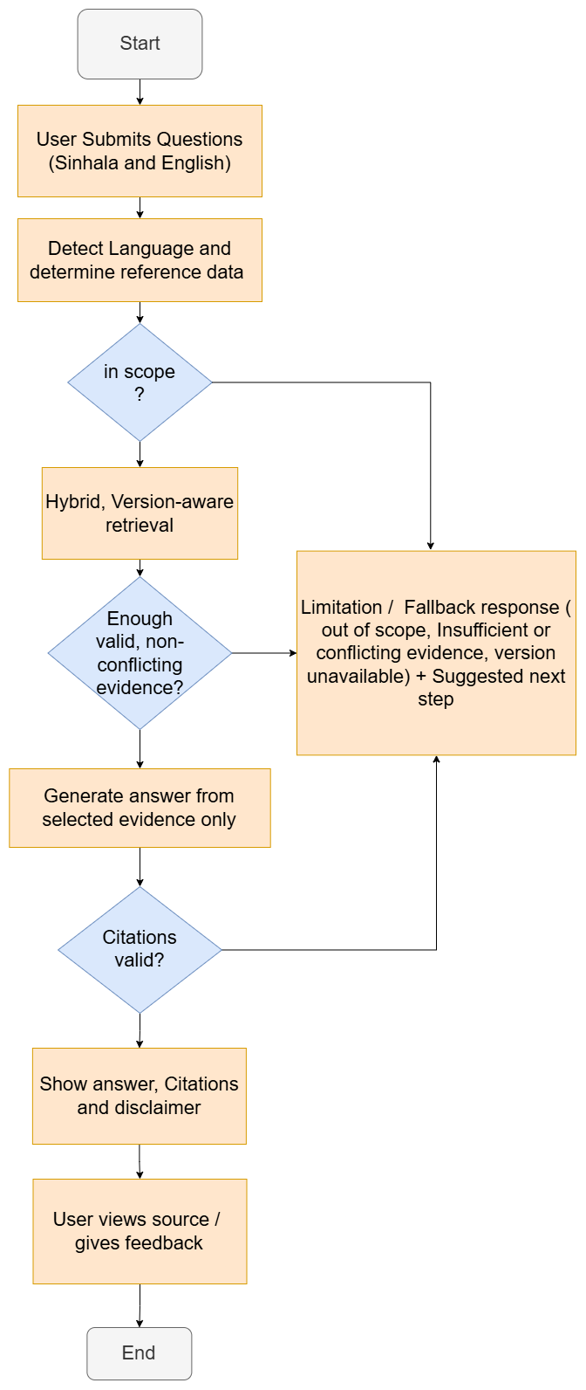
Figure 3.0.3 Question answering activity flow

3.7 Safe Handling of Unsupported Questions
The system shall not invent answers when suitable legal evidence is not available.
- The system shall detect questions outside the defined business-name registration scope and inform the user.
- The system shall inform the user when there is not enough legal evidence to answer the question.
- The system shall inform the user when the retrieved legal evidence is conflicting.
- The system shall inform the user when the legal version for the selected date is not available.
- In these situations, the system shall give a suitable limitation or fallback response, such as recommending a lawyer or the Registrar of Business Names.
- The system shall log all unsupported questions so the team can identify gaps in the legal content.

3.8 Legal Document Ingestion and Processing
The administrator shall be able to add official legal documents, which the system processes and prepares for review. The legal content workflow from upload to publication is shown in Figure 6.
- The administrator shall be able to upload official legal documents in PDF, DOCX or text format.
- The system shall record the details of each document, such as title, law number, year, language and source.
- The system shall extract the legal text and its structure from the document.
- The system shall remove unnecessary content such as page headers, footers and layout errors.
- The system shall preserve useful information such as sections, subsections, page numbers and tables.
- The system shall use OCR, including Sinhala OCR, for scanned documents.
- The processed content shall be marked for review before it can be used.
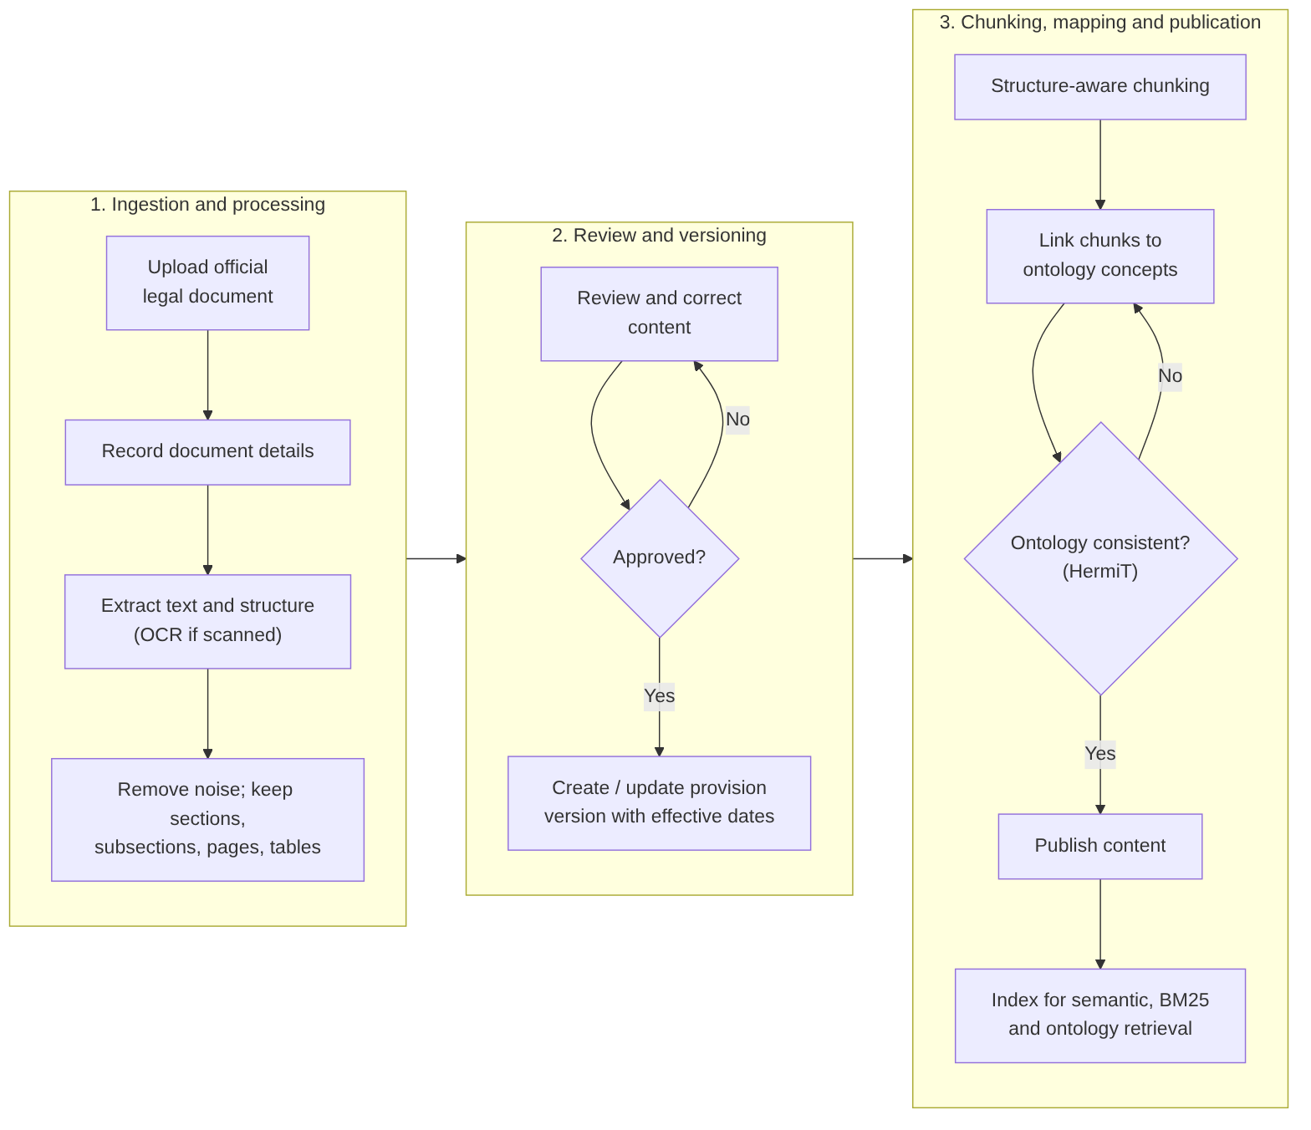
Figure 3.4 Legal content workflow from upload to publication

3.9 Structure-Aware Legal Chunking and Indexing
The system shall divide reviewed legal content according to its legal structure and make it available for retrieval.
- The system shall divide legal content mainly by sections and subsections.
- Large provisions shall be divided further while keeping a link to their parent provision.
- Each chunk shall keep its details, such as law title, section number, version, effective dates and page reference.
- Each chunk shall have a unique ID.
- The system shall reindex the affected chunks when legal content is changed.

3.10 Legal Knowledge Review and Publication
The administrator shall review and correct processed legal content before it becomes available to users.
- The administrator shall be able to view the processed legal content and its detected structure.
- The administrator shall be able to correct errors in the text, structure or details.
- The administrator shall be able to approve and publish reviewed content.
- Only reviewed and published content shall be searchable by the public system.
- Unreviewed legal content or updates shall never be published automatically.
- The system shall record who reviewed and published each item, and when.

3.11 Provision Version Management
The administrator shall manage new versions of legal provisions when the law changes.
- The administrator shall be able to create a new version of a provision when an amendment or updated rule is introduced.
- When a new provision version is introduced, the system shall allow the administrator to specify the legal relationship between the existing and new versions, including amendment, replacement, repeal, or continuation, based on verified legal sources.
- Each version shall have an effective-from date and, where applicable, an effective-to date.
- The system shall keep previous versions and their effective periods instead of replacing them.
- The system shall prevent two versions of the same provision from being valid for the same period.
- The system shall record the reason for each new version, such as the amending law.

3.12 Ontology and Evidence Mapping Management
The administrator shall maintain the ontology and its links to the supporting legal evidence.
- The administrator shall be able to add and update ontology concepts and relationships.
- The administrator shall be able to manage Sinhala and English labels and synonyms for each concept.
- The administrator shall be able to create, view and correct the links between ontology concepts and legal evidence.
- The system shall validate the ontology for logical consistency using an OWL reasoner, such as HermiT, before an updated ontology version is approved for use.
- The system shall report any legal evidence that is not linked to an ontology concept.
- Each ontology version shall be numbered, so changes can be tracked

3.13 Privacy-Protective Query Processing

The system shall protect sensitive information contained in user questions by performing local Personally Identifiable Information (PII) detection and masking before the question is processed by the language model. Sensitive information shall be restored only when necessary and only within the controlled local application environment.
- The system shall inspect submitted questions for supported sensitive identifiers, including Sri Lankan National Identity Card (NIC) numbers, Taxpayer Identification Numbers (TINs), and other explicitly configured identification patterns.
- The system shall replace detected sensitive identifiers with temporary placeholders before the question is submitted to the language model.
- The system shall maintain the relationship between placeholders and original values within a temporary local mapping that is not transmitted to any external AI service.
- The system shall restore original values in the final response only when necessary and when the placeholder mapping can be performed safely.
- The system shall discard temporary placeholder mappings after completion of the corresponding request, including when processing fails.
Limitations
The initial masking mechanism may use regular expressions and configurable identifier patterns. It is not expected to identify every form of personal or confidential information, particularly unrestricted Sinhala text, business secrets, or context-dependent sensitive details.
Therefore, the system shall not represent the masking process as a guarantee that all sensitive information has been removed.

4. Non-Functional Requirements
The non-functional requirements describe the performance, security, reliability, usability, maintainability, compatibility, and operational characteristics expected from the proposed application.
Performance targets included in this version are provisional and must be validated using the actual development hardware and finalized benchmark.

4.1 Performance and Load Requirements
- Response Time
For the approved local demonstration hardware, the system should return at least 95% of warmed-up, single-user, in-scope responses within 30 seconds.
The threshold shall be reviewed following initial performance testing.
- Retrieval Reproducibility
The retrieval pipeline shall provide reproducible results for an unchanged source corpus, ontology mapping set, and retrieval configuration, subject to documented model behavior.
- Performance Measurement
Evaluation results shall identify the relevant hardware configuration, model versions, source corpus size, memory resources, and retrieval settings.
The initial prototype will be designed primarily for single-user demonstration and evaluation. Concurrent-user capacity may be investigated after basic system functionality is established.

4.2 Compatibility Requirements
- Local Platform Compatibility
The system shall operate on the selected documented local operating system and hardware with exception of only requiring an external LLM inference service.
The frontend shall support at least one modern desktop web browser.
The development team shall document the minimum operating system, software dependency, model, memory, and storage requirements after technology feasibility testing.

4.3 Certification Requirements
- No formal government, legal, financial, or industry certification is required for the initial academic prototype.
- The system shall not claim to be an officially certified legal advisory platform or a government-endorsed service.
- The project team shall identify applicable licensing, security, and software compliance requirements during development.

4.4 External Interface Requirements

4.4.1 User Interfaces
- User Interface
The system shall provide a responsive web interface containing a question input area, language handling, answer display, supporting citations, disclaimer information, and relevant error messages.
The administrator interface shall support document staging, source registration, review, approval, indexing, and version-history inspection.
The user interface should use consistent terminology, readable typography, and clear interaction states.

4.4.2 Hardware Interfaces
The proposed system does not require specialized hardware devices, sensors, or audio equipment.
The minimum required hardware interfaces consist of standard computer input and display devices.
GPU acceleration may be used for model inference or embedding computation when supported by the development hardware. Exact hardware requirements remain subject to feasibility testing.

4.4.3 Software Interfaces
- Internal Software Interfaces
The system shall provide documented interfaces between the frontend, backend API, query processor, retrieval engine, ontology interface, document repository, metadata storage.
Internal requests and responses shall use consistent structured data formats and provide appropriate error information.
Generated response data should include answer text, output language, citation objects, source-version identifiers, and refusal or error details when applicable.

4.4.4 Communications Interfaces
- Local Network Communication
The application shall operate through local communication interfaces, including loopback or an explicitly approved local network configuration.
If the application is exposed over a local area network, appropriate authentication and encrypted communication shall be configured.
External telemetry and third-party model inference services shall remain disabled unless separately approved.

4.5 Security and Authentication Requirements

4.5.1 Data Storage Security
- Stored Data Protection
The application shall protect source documents, retrieval indexes, credentials, and administrative records using appropriate access controls.
Administrator passwords shall not be stored as plaintext.
The initial prototype shall avoid storing confidential applicant details or other unnecessary personal information.

4.5.2 Data Communication Security
- Input and Communication Security
The system shall validate user input and uploaded documents to reduce the risk of malformed content, unsupported file types, oversized uploads, unauthorized access, and directory traversal.
Retrieved documents shall be treated as evidence rather than as instructions controlling application behavior.

4.5.3 Authentication
- Administrator Authentication
Administrative functions shall require authenticated access.
The authentication mechanism shall support appropriate password handling, session management, session expiration, and logout functionality.
Public information users shall not be required to authenticate for ordinary question answering functions.

4.6 Quality Assurance Requirements

4.6.1 QA Test Scope
- Testing Requirements
The project shall include unit testing, integration testing, system testing, authorization testing, document-version validation, multilingual query testing, citation verification, and benchmark-based evaluation.
Testing shall cover normal operation and abnormal scenarios, including unavailable retrieval indexes, failed document extraction, insufficient evidence, unsupported input, and language-model errors.

4.6.2 QA Environment
Testing shall be conducted in a documented local environment containing the approved source corpus, ontology, retrieval indexes, model files, application components, and test configurations.
The evaluation environment shall use controlled software dependencies and a consistent benchmark dataset.

4.6.3 QA Data
A provisional evaluation dataset of approximately 60 human-reviewed question cases is proposed.
The dataset should contain English questions, Sinhala questions, selected mixed language terminology cases, intentionally unsupported questions, and questions involving source applicability or version validity.
At least 15 answerable questions should have paired English and Sinhala versions.
Each answerable test question shall be associated with reviewed supporting source provisions and relevant applicability assumptions.
The final dataset size, distribution, review procedure, and acceptance thresholds remain subject to team and supervisor approval.

4.7 Development Requirements

4.7.1 Development Environment
- Development Environment
The application shall be developed using documented, version-controlled tools and dependencies capable of operating locally.
The proposed technology stack is summarized below.
Table 4.1 Proposed technology stack
Component | Proposed Technology | Purpose
Frontend | React, TypeScript, Tailwind CSS | Web-based user and administrator interfaces
Backend | Python, FastAPI | Application APIs and workflow orchestration
Ontology Development | Protégé | Formal ontology construction and validation
Ontology Representation | OWL / RDF | Structured domain knowledge
Ontology Integration | RDFLib | Ontology access, queries, and relationship processing
Document Parsing | Docling | Extraction of structured source documents
Normalization / Chunking | Local Implementation | Cleans and normalizes extracted legal text, divides it into meaningful, structure-aware chunks for accurate retrieval and citation.
Database | PostgreSQL | Structured metadata storage
Vector Retrieval | PostgreSQL + pgvector | Dense semantic search
Keyword Retrieval | BM25 | Lexical search
Retrieval Fusion | Reciprocal Rank Fusion (RRF) | Combining ranked retrieval results
Reranking | bge-reranker-v2-m3 | Candidate relevance refinement
Embedding Model | BGE-M3, 1024-d, local | Semantic representation across languages
Local LLM | Groq API | Grounded answer generation
PII Redaction / Pseudonymization | Python (re / regular expressions), custom Sri Lankan identifier validation rules, request-scoped placeholder mapping | Local detection and masking of configured NIC, TIN, email and phone identifiers before downstream query/LLM processing; selective restoration after response validation
Testing | pytest + ruff | Functional verification and benchmarking
Version Control | Git, GitHub | Team collaboration

4.7.1.1 PII Redaction Implementation Note
The privacy component will use locally executed regex patterns and contextual checks for configured identifier formats. A temporary placeholder-to-original mapping should remain outside the LLM context and be discarded after the request.
Because regex cannot reliably recognize arbitrary names or confidential free text, its detection scope and limitations shall be tested on synthetic English, Sinhala and Singlish questions.

4.7.2 Development Data
The development dataset shall consist of approved legal source documents, extracted provisions, document metadata, ontology concepts, verified concept-to-evidence mappings, and benchmark questions.
A source registry shall preserve available provenance information, including issuing authority, publication details, source URL, retrieval date, document hash, amendment references, jurisdiction, and approval status.

4.7.3 Coding Standards
- Coding Practices
The development team shall use consistent naming conventions, version control, code formatting, documentation, testing practices, and code review procedures.
Core retrieval logic and document-processing functions shall be covered by automated tests where practical.
Changes to authoritative ontology mappings should undergo review before activation.

4.7.4 Implementation Packaging Requirements
The completed prototype shall include installation instructions, documented dependencies, configuration examples, database initialization procedures, ontology-loading instructions, and source-index initialization scripts.
Software and model licensing restrictions shall be respected.

4.8 Deployment Requirements

4.8.1 Installation Packaging Requirements
- Local Installation
The system shall provide a documented installation procedure for initializing the application, local databases, retrieval indexes, approved ontology, and model runtime.
Containerized deployment may be used if compatible with the agreed development hardware.

4.8.2 Deployment Requirements
The initial system shall operate on a local development workstation or controlled local network.
The deployment environment shall document the operating system, CPU, RAM, available GPU resources, storage capacity, model requirements, application configuration, and backup arrangements.
Public cloud deployment is excluded from the initial project scope.

4.8.3 Documentation Requirements
The project shall deliver installation instructions, administrator guidance, source-management procedures, ontology documentation, evaluation procedures, software architecture documentation, and the final technical report.

4.9 Internationalization Requirements
- Language Support
The application shall support Unicode English and Sinhala text input and output.
The system shall preserve reviewed English and Sinhala ontology labels and support controlled normalization of selected Sinhala-English mixed-language terminology.
Tamil-language processing and audio interaction are excluded from the initial prototype.

4.10 System Activity Log Requirements
- Logging
The system shall log important administrative operations, including authentication events, source imports, approval decisions, ontology mapping updates, index rebuilding, document activation, and relevant processing failures.
Logs shall avoid unnecessary personal information.
Raw user-question retention shall be disabled by default unless an approved evaluation or diagnostic policy requires otherwise.

4.11 Special Documentation Requirements
- The application shall present a clear disclaimer explaining that generated responses are intended for informational purposes and do not constitute professional legal advice.
- The application shall identify the prototype's scope and provide source references for generated explanations.
- Where relevant, the system shall acknowledge uncertainty concerning applicable source versions, jurisdictions, or supporting evidence.
- The application shall not claim official endorsement by any government institution.

4.12 Applicable Standards
The system shall consider relevant standards and technical recommendations relating to,
- RDF and OWL knowledge representation.
- Secure web application design.
- Unicode and multilingual text handling.
- Accessibility and usability.
- Software quality assurance.
- Appropriate software and model licensing.
The specific standards and versions adopted during implementation shall be documented in the final technical specification.

4.13 Licensing Requirements
- License Compliance
All selected software libraries, development tools, language models, embedding models, document parsers, and supporting components shall be reviewed for their applicable licensing conditions.
The system shall not redistribute restricted model weights, proprietary assets, or source documents without appropriate permission.

4.14 Online User Documentation and Help System Requirements
The application should provide a basic help section explaining the supported subject area, example questions, language support, source citations, privacy expectations, and limitations of generated responses.
Administrator documentation shall explain document import, approval, indexing, version activation, and recovery procedures.

4.15 Purchased Components
The proposed baseline does not require purchased software components.
Open-source or locally executable components will be preferred, provided that they satisfy the system's technical requirements.
Any future use of commercial components shall require a review of cost, licensing, compatibility, and the local-only deployment constraint.

4.16 Technical Requirements
- Source Metadata and Integrity
Each indexed document chunk shall retain sufficient metadata to identify its source document, relevant provision, document version, approval status, and source location.
Where verified, the system shall also preserve effective-date information and applicable jurisdiction.
Ontology concepts shall be connected to source evidence through explicit, reviewable mappings.
The retrieval pipeline shall not treat unverified or inapplicable material as approved current evidence.

4.17 Supportability Requirements
The system shall provide diagnostic information, reproducible indexing procedures, configuration documentation, and backup and restoration instructions.
The architecture should allow retrieval models and software components to be replaced without requiring unnecessary changes to the legally reviewed ontology.

4.18 Reliability Requirements
- Fault Handling and Recovery
The system shall handle unavailable models, corrupted indexes, missing citation metadata, invalid source versions, and document-processing failures without generating unsupported legal conclusions.
Failed reindexing or document activation shall not remove the last successfully approved source collection.
The system shall support local recovery procedures appropriate to the prototype environment.

4.19 Usability Requirements
The application shall provide a straightforward interface through which a first-time user can submit a question, interpret the response, and access the associated citations without specialized technical knowledge.
Sinhala text shall be displayed legibly using suitable Unicode-compatible fonts.
A small moderated usability evaluation involving approximately five participants is proposed, subject to team and supervisor approval.

5. Pilot Success Criteria
The pilot evaluation will test the prototype using a lawyer-validated test set of 80–100 questions in Sinhala and English, together with ontology checks and a usability study with SME users. The prototype will be considered successful if it meets the following criteria,
- Answer accuracy: - at least 80% of answers are judged fully correct by the legal validator.
- Citation correctness: - at least 90% of citations point to the correct law, section and version, and support the statement made.
- Hallucination rate: - no more than 5% of answers contain an unsupported or incorrect legal statement.
- Version correctness: - at least 95% of date-based questions return the provision version that was valid on the selected date.
- Safe handling: - at least 90% of out-of-scope or unanswerable questions receive a correct limitation or fallback response.
- Bilingual performance: - the accuracy difference between Sinhala and English questions is no more than 10 percentage points.
- Ontology quality: - no logical errors are found by the HermiT reasoner, and all competency questions are answered correctly.
- Usability: - an average System Usability Scale (SUS) score of 68 or above.
- Response time: - most answers are returned within 10 seconds.

5.1 Planned Controlled Comparisons
To show the contribution of each part of the system, the following comparisons will be carried out using the same test set, legal content and language model,
- Plain RAG vs ontology-enhanced RAG (main comparison): - measures whether the ontology improves answer accuracy and citation correctness, and reduces hallucination.
- With vs without version-aware retrieval: - measures whether date-based version filtering returns the correct version of the law.
- Hybrid retrieval vs single methods: - compares semantic search only, BM25 only and the full hybrid method (semantic, BM25 and ontology, with reranking), to show the value of combining them.
- Sinhala vs English questions: - compares system performance across the two languages using matching question pairs.
- Structure-aware vs fixed-size chunking: - measures whether dividing legal text by sections and subsections improves retrieval and citation quality.

6. Future Requirements
The following improvements are outside the scope of this prototype but are planned for future versions of the system,
- Wider legal coverage: - extend the system to other SME legal areas, such as company registration, tax registration, employment law and EPF/ETF obligations.
- More business types: - add support for companies and other business structures.
- Tamil language support: - add Tamil as a third language, so the system serves all of Sri Lanka’s official languages.
- Automatic legal update monitoring: - detect new amendments published in the Government Gazette, with administrator review before they are used.
- Locally hosted language model: - use an open-source language model hosted locally to reduce cost and keep data within Sri Lanka.
- Mobile and messaging access: - provide a mobile application, a messaging channel such as WhatsApp, and voice input and output.
- Deadline reminders: notify users of upcoming legal deadlines based on their business details.
- Lawyer consultation summary: - allow users to export a summary of their questions and answers to share with a lawyer, making consultations faster and more effective.
- Integration with government services: - connect with official online registration services if suitable interfaces become available.

7. References
[1] Ministry of Industry and Entrepreneurship Development, National SME Strategy Framework: A Thriving Nation – A Beautiful Life, Ver. 1.0. Colombo, Sri Lanka: MOIED, 2026.
[2] P. Lewis et al., “Retrieval-augmented generation for knowledge-intensive NLP tasks,” in Proc. Adv. Neural Inf. Process. Syst. (NeurIPS), vol. 33, 2020, pp. 9459–9474.
[3] Business Names Ordinance, No. 6 of 1918, Chapter 149, Legislative Enactments of Ceylon.
[4] W3C OWL Working Group, “OWL 2 Web Ontology Language document overview (second edition),” W3C Recommendation, Dec. 2012. [Online]. Available: https://www.w3.org/TR/owl2-overview/
[5] S. Harris and A. Seaborne, “SPARQL 1.1 query language,” W3C Recommendation, Mar. 2013. [Online]. Available: https://www.w3.org/TR/sparql11-query/
[6] J. Brooke, “SUS: A ‘quick and dirty’ usability scale,” in Usability Evaluation in Industry, P. W. Jordan, B. Thomas, B. A. Weerdmeester, and I. L. McClelland, Eds. London, U.K.: Taylor & Francis, 1996, pp. 189–194.
[7] A. R. Hevner, S. T. March, J. Park, and S. Ram, “Design science in information systems research,” MIS Quart., vol. 28, no. 1, pp. 75–105, 2004.
[8] K. Peffers, T. Tuunanen, M. A. Rothenberger, and S. Chatterjee, “A design science research methodology for information systems research,” J. Manage. Inf. Syst., vol. 24, no. 3, pp. 45–77, 2007.
[9] B. Glimm, I. Horrocks, B. Motik, G. Stoilos, and Z. Wang, “HermiT: An OWL 2 reasoner,” J. Autom. Reasoning, vol. 53, no. 3, pp. 245–269, 2014.
[10] R. Hoekstra, J. Breuker, M. Di Bello, and A. Boer, “The LKIF core ontology of basic legal concepts,” in Proc. Workshop Legal Ontologies Artif. Intell. Techn. (LOAIT), Stanford, CA, USA, 2007, pp. 43–63.
[11] S. Robertson and H. Zaragoza, “The probabilistic relevance framework: BM25 and beyond,” Found. Trends Inf. Retr., vol. 3, no. 4, pp. 333–389, 2009.
[12] A. Bangor, P. T. Kortum, and J. T. Miller, “An empirical evaluation of the System Usability Scale,” Int. J. Hum.–Comput. Interact., vol. 24, no. 6, pp. 574–594, 2008.

